**Department of Veterans Affairs**

**Innovation 873**

**Telepathology**

**VistA Imaging 3.0**

**Telepathology Configurator**

**User Manual**



**September 2015**

Revision History

| Date | Revision | Description | Author |
| --- | --- | --- | --- |
| 09 Sep 2015 | 1 | New document. | Arianna Sunbear |

Contents

1 Introduction 5

2 Telepathology Configurator Overview 5

2.1 Key Functions 5

2.2 Logging In and Permissions 6

2.3 Message Log 6

2.4 Getting Help 7

3 Configuring “Who Do I Read For” Sites 7

3.1 Adding a “Who Do I Read For” Site 7

3.2 Inactivating or Deleting a “Who Do I Read For” Site 8

4 Configuring “Who Reads For Me” Sites 9

4.1 Adding a “Who Reads For Me” Site 9

4.2 Inactivating or Deleting a “Who Reads For Me” Site 10

5 Configuring Report Templates 11

5.1 How to change a template 12

6 Changing Worklist Settings 13

# Introduction

This document explains how to use the VistA Imaging Telepathology Configurator as expanded in the VA Innovations 873 Program as a follow-up to patch MAG*3.0*138.

**Note:** This document covers the functions of the Configurator only. It does not address pathology-related aspects of the Lab Package or local pathology functions beyond those affected by the Configurator.

**Note:** This document assumes that the Configurator is already installed on a VA policy-compliant computer that can access the VistA system at your site.

This document is intended for IT staff who are responsible for configuring the VistA Imaging Telepathology Worklist as implemented for the VA Innovations 873 Program. This document assumes a general understanding of Telepathology workflow, the VistA MAG Package, and the VistA LAB Package.

# Telepathology Configurator Overview

## Key Functions

The Telepathology Configurator is used to:

* Allow your site to read Surgical Pathology (SP), Electron Microscopy (EM), and Cytopathology (CY) cases for other sites. For more information, see section 3.
* Allow other sites to read Surgical Pathology (SP), Electron Microscopy (EM), and Cytopathology (CY) cases for your site. For more information, see section 4.
* Define templates used by Telepathology Worklist for reports for Surgical Pathology (SP), Electron Microscopy (EM), and Cytopathology (CY) cases. For more information, see section 5.
* Define timeouts and retention periods for users of Telepathology Worklist at your site. For more information, see section 6.

Settings in the Configurator are stored in your site’s VistA database. Communications between the Configurator and your VistA system are mediated by your site’s local VIX (VistA Imaging eXchange server).

## Logging In and Permissions

To start the software, choose **Start | All Programs | VistA Imaging Programs | VistA Imaging Telepathology Configurator**.

The Telepathology Configurator uses the standard VistA login process.

To access the Configurator application, you will need a local VistA account with the MAGTP WORKLIST MGR menu option and the MAG SYSTEM and LRLAB keys assigned.

Note that:

* The Configurator is not CCOW-enabled as it does not show patient-specific data.
* The Configurator does not have an inactivity timeout.

## Message Log

Use the Configurator **View | Message Log** option to view user- and system-level Configurator session log messages, and if needed to gather information for error correction.

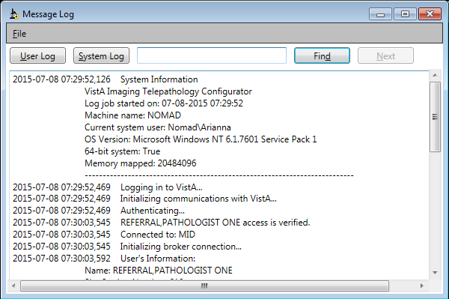

* The User Log has a white background and is shown by default.
* The System Log has a tan background and is shown by clicking the **System Log** button.
* You can search within a displayed log using the controls near the top right of the Message Log window.
* You can select and copy/paste log information from this the Message Log window into an outside text editor if needed.

## Getting Help

If you encounter problems the application, contact your local support staff. If the problem cannot be resolved locally, use Remedy to place a service request, or the VA help desk at 1-888-596-4357.

For version information for the Telepathology Configurator software , use the **Help | About** menu option.

# Configuring “Who Do I Read For” Sites

By default, the Telepathology Worklist shows only the pathology cases for your site. To let your site read (interpret or consult) pathology cases for other remote sites, you will need to set up one or more entries in the Configurator Who Do I Read For tab.

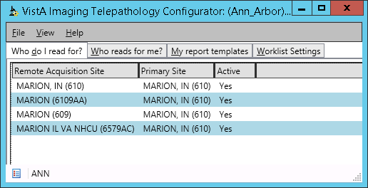

Entries defined using this tab are stored in the MAG PATH CONFIG file (#2006.13).

## Adding a “Who Do I Read For” Site

1. Determine the name of the remote acquisition site that you want to interpret or consult for.
   * + This is the site that acquires/stores the pathology specimens that are in need of interpretation or consultation.
     + The site name must match an entry in the local INSTITUTION File (#44).
2. Determine if the remote acquisition site has a primary (i.e. parent) division..
   * + If no, skip to the next step.
     + If yes, determine the name of the primary site. (The name of the primary site must match an entry for a primary site in the local INSTITUTION File (#44).)
3. **IMPORTANT:** Contact the remote site that you intend to read for. They will need to create a complementary entry in their Configurator Who Reads For Me tab that points to your site.
4. Go to the Telepathology Configurator, and in the Who do I Read For tab, click **Add**.
5. In the Acquisition Site Editor dialog, do the following:
   1. In the first box, enter the name of the remote acquisition site you identified in step 1 above.

**Tip:** To quickly locate a name, start typing the first characters in the site name as it is listed in the local INSTITUTION File (#44).

* 1. In second box, enter the name of the remote acquisition site’s primary division.

**Note:** If the remote acquisition site IS a primary site, the name in both boxes will be the same.

* 1. Check the setting in the **Active** checkbox. If you want to immediately start polling the remote site for worklist data, leave this box checked (enabled).
  2. Click **Add**.

1. In the Who do I Read For tab, verify the values are set as desired.
2. Once the new entry is set to Active, contact the remote site and ensure that they can access case data from your site.

## Inactivating or Deleting a “Who Do I Read For” Site

If you want to temporarily stop accessing case information from a site, you can make that site inactive. To make the change permanent, you can delete the site entry.

1. For the site in question, ensure that all consultations or interpeatations for that site are completed (i.e., there are no cases from that site on your site’s Unread worklist). You will not be able to inactivate or delete “Who Do I Read For” until all cases are completed.
2. Go to the Telepathology Configurator, and in the Who do I Read For tab, locate the entry for the site you want to inactivate or delete.
3. Do one of the following:
   * + To inactivate the site, select the entry, and click **Edit**. In the Acquisition Site Editor dialog , disable the **Active** check box, then click **Update**.
     + To delete the site select the entry and then click **Remove**.
4. Contact the remote site and have them make the equivalent changes in their “Who Reads for Me” tab.
5. After the site is inactivated or removed:
   * + The inactivated/deleted site will no longer be able to request consultations from your site.
     + Data for completed cases from the inactivated/deleted site will remain accessible from the Read list until the retention period is reached.

# Configuring “Who Reads For Me” Sites

Use the “Who Reads For Me” tab to define which remote sites you can request pathology consultations from. Also use this tab if you want your pathology cases to be interpreted by one or more remote sites.

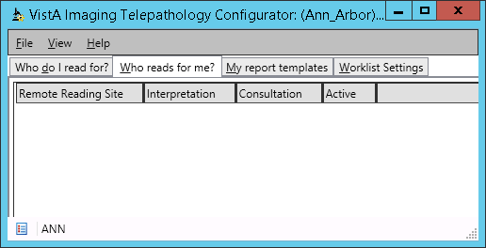

Entries defined using this tab are stored in the MAG PATH CONFIG file (#2006.13).

## Adding a “Who Reads For Me” Site

1. Determine the name of the remote site that will be receiving pathology case data from your site (the sites you will be resting consultation from, or that will be interpreting your cases for you).

**Note:** The remote site name must match an entry in your local INSTITUTION File (#44).

1. Determine if the pathologists at the remote site will be interpreting or consulting for your site (or both).
   * + If the remote pathologists will be entering a primary (main) report, they will be interpreting for your site.
     + If the remote pathologists will be adding supplementary entries to an existing report, they will be consulting for your site.
2. **IMPORTANT:** Contact the remote site that will be handling your cases. They will need to create a complementary entry in their Configurator Who Do I read For tab that points to your site.
3. Go to the Telepathology Configurator, and in the Who Reads For Me tab, click **Add**.
4. In the Reading Site Editor dialog, do the following:
   1. In the Select Reading Site box, enter the name of the remote reading site you identified in step 1 above.

**Tip:** To quickly locate a name, start typing the first characters in the site name as it is listed in the local INSTITUTION File (#44).

* 1. In the Type box, choose if the site will be interpreting for you, consulting for you, or both as determined in step 2 above.
  2. Check the setting in the **Active** checkbox. If you want to immediately start sending your data to the remote sites Telepathology Worklist, leave this box checked (enabled).
  3. Click **Add**.

1. In the Who Reads For Me tab, verify the values are set as desired.
2. Once the new entry is set to Active, contact the remote site and ensure that they can access case data from your site.

## Inactivating or Deleting a “Who Reads For Me” Site

If you want to prevent another site from accessing case information from your site, you can make that site inactive, or you can permanently remove that site from your Who Reads For Me tab.

1. Go to the Telepathology Configurator, and in the Who Reads For Me tab, locate the entry for the site you want to inactivate or delete.
2. Do one of the following:
   * + To inactivate the site, select the entry, and click **Edit**. In the Reading Site Editor dialog , disable the **Active** check box, then click **Update**.
     + To delete the site select the entry and then click **Remove**.
3. Contact the remote site and have them make the equivalent changes in their “Who do I read for” tab.
4. After the site is inactivated or removed:
   * + New cases will no longer be sent to the inactive/deleted site for interpretation (if that site was set up for interpretation).
     + Your site will no longer be able to request consultations from the inactive/deleted site for new cases.
     + In-progress cases being interpreted or awaiting consultation will remain on your site’s and on the inactive/deleted site’s Unread List until they are completed/verified or until a consultation is declined by the inactive/deleted site.
     + Data for completed cases will be accessible from your site’s and on the inactive/deleted site’s Read list until the retention period is reached.

# Configuring Report Templates

Use the My Report Templates tab to change the report templates for Surgical Pathology (SP), Electron Microscopy (EM), and Cytopathology (CY) case types.

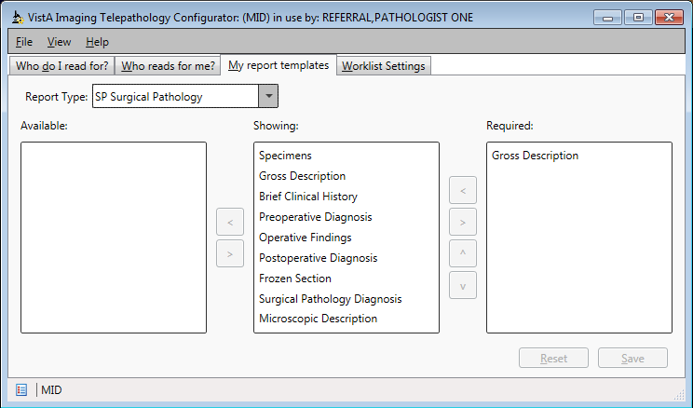

Each report template determines which report sections are present, which sections are required, and the order in which sections are listed in a report.

Note: It is recommended that the “Gross Description” section be moved to the top of the **Showing** list for each template.

These templates are applied when the Telepathology Worklist application is used to enter or update reports for cases accessioned at your site. [1] The templates themselves are stored in the MAG PATH CONFIG file (#2006.13).

## How to change a template

To change a template, do the following:

1. Go to the My Report Templates tab and use the **Report Type** box to select the template you want to change.
2. To control which sections are present in the report, use the Left button and Right button buttons to shift each field into the Available, Showing, or Required box.
   * + Available – section is excluded from report.
     + Showing – section is present in the report.
     + Required – section is present in the report and must be populated before a report is completed.

Note: It is recommended that the “Gross Description” section be moved to the top of the **Showing** list for each template. The Gross Description field is always required and cannot be moved from the Required box.

Note: You can use the **Reset** button to revert to the previously saved version of a report template.

1. To control the order sections are shown in the report, select an item in the Showing box and use the Up button and Down button buttons to move the item up and down in the list.
2. When you are finished, click **Save**.
   * + Changes will be applied to new reports.
     + Changes will not alter existing reports if data was entered into a section impacted by the template change.

# Changing Worklist Settings

Use the Worklist Settings tab to set report lock duration, worklist timeout, and read list retention periods.

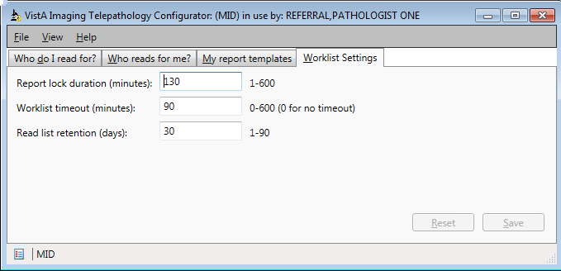

To change a setting, enter the desired value and choose **Save** to apply the change. The changes will not apply to current running instances of the Telepathology Worklist, but will be applied the next time a user logs into the Worklist application.

These settings affect worklist behavior for the local site only. Each setting is described in detail below.

| Other tab setting | Value | Notes |
| --- | --- | --- |
| Report lock duration | 1 – 600 minutes (30 default) | Specifies how long a user can lock (have exclusive access to) the reporting or coding functions of a case. A lock is applied automatically after a user chooses Edit Report in the Telepathology worklist.  The lock is retained for as long as the reporting window is open or until the specified duration is reached, whichever comes first. One minute before the specified duration, the user is warned that the lock will expire and given the option to reset the lock. If the lock is allowed to expire, any unsaved changes are automatically saved, the report window is closed, and the lock is removed.  Note: A locked report can still be edited using the Lab package roll-and-scroll interface. There is currently no way to inform a roll-and-scroll user that a report is being edited in the Worklist, or vice versa.  A user who holds the LRAPSUPER key can override a report lock using the Telepathology Worklist. |
| Worklist timeout | 0 – 600 minutes (30 default) (0 for no timeout) | Specifies how long an instance of the Telepathology Worklist application remains running. After the amount of time specified, a warning box is displayed for one minute. If the user takes no action, the application closes and the user is logged out.  This setting is stored in the TIMEOUT WINDOWS TELEPATHOLOGY field (#135) of the IMAGING SITE PARAMETERS file (#2006.1). |
| Read list retention | 1 – 90 days (30 default) | Specifies how many calendar days released are cases shown in the Read list tab in the Telepathology Worklist. Note that a locally applied user filter could be used to further limit what is shown in the Worklist application.  This setting is stored in the field TELEPATH UNREAD-RETENTION DAYS (#134) of the IMAGING SITE PARAMETERS file (#2006.1). |

1. These settings apply when the Telepathology Worklist GUI is used. These settings do not affect automatically generated reports or reports edited directly in the LAB Package roll-and-scroll interface.